NORTH WILTSHIRE VILLAGES FLOWER CLUB

2026 Programme
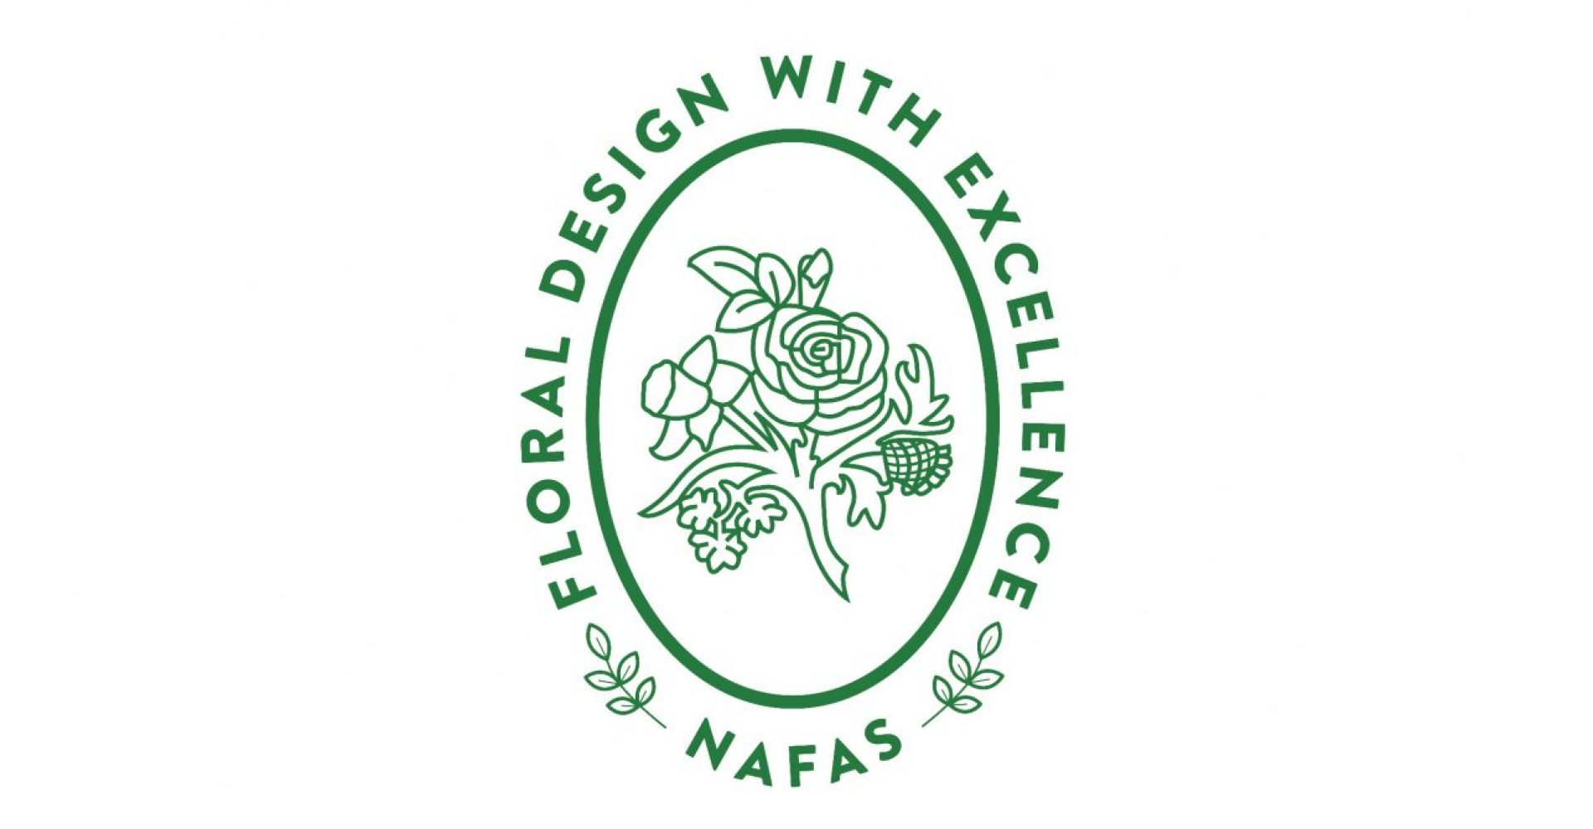

Email: nwvflowerclub@gmail.com
northwiltshirevillagesflowerclub.co.uk

Committee Members
Janet Bentley | (Chairman)
Cathy Carroll | Margaret Stanford
Jo England | Marguerite Whyte
Diana Hodgson | Louise Williams
Liz Parker | Veronica Chandler

We meet on the third Wednesday of each month, usually at Crudwell Village Hall, 7 for 7.30pm, plenty of free adjacent parking – SN16 9HB.
Best Bloom Competition on the evenings we have demonstrations
Annual Membership £48
Visitors very welcome £8.00 per meeting
Raffle, Plant and Sales Table at most meetings
Complimentary tea/coffee and cake/biscuits

November 19th 2025 OPEN Meeting “Myths, Mincet and Merriment” by Katherine Kear
December 17th 2025 Christmas Lunch
Old Royal Ship, Luckington

January 21st 2026 Tetbury Flower Company
Talk on growing dahlias
February 18th 2026 Demonstration
Cathryn Brown - A Flower Prescription for You
March 18th 2026 Demonstration
Arnaud Matairie - From Ekhaya to You
April 15th 2026 Workshop
By the Club, For the Club
May 20th 2026 Demonstration
Jackie Page – Connections
June 17th 2026 Demonstration
Fleur White – Musical Memories
July 1st 2026 Summer Outing
Visit to David Austin Roses
August 19th 2026 Workshop
Coral Gardiner – Pedestal Workshop
September 16th 2026 AGM Jenny from Halliesphere Ltd. (Talk & Demo)
October 21st 2026 Workshop Brinkworth Willow - Wreath making
November 18th 2026 OPEN Meeting
Nick Grounds - Jingle a Partridge with Tinsel
December 16th 2026 Christmas Lunch

